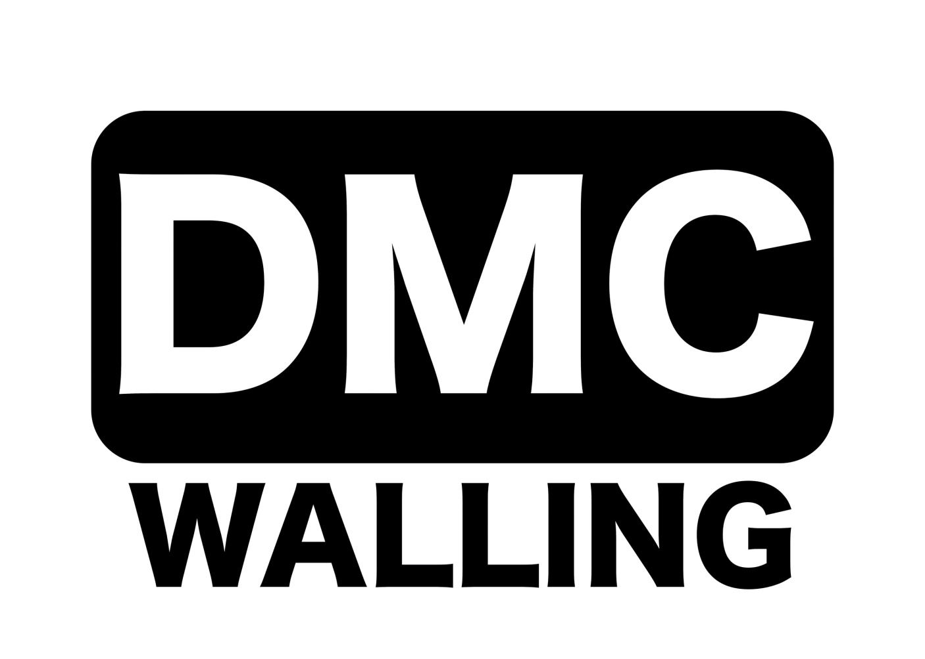
Founded 1900
Promoted for and on behalf of Cycling Time Trials under their Rules & Regulations

RESULTS
VICTORIA CYCLING CLUB

Co-Sponsored by DMC Walling, Alfresco Europe Solutions

Results for 27th August 2022

10.2m 2-Up T.T.T/Solo Scratch - Points League #2 of #3

EVENT H.Q. Open 6.30am EVENT SECRETARY:Andrew Beaman ASSIS. EVENT SECRETARY:
Lea valley cycling hut 8 Colson road Sean Gray
Loughton IG103RN
North Hall Road
Ugley, Essex Mobile: 07723392837 Mobile: 07917-828944
CM22 6JD
Timekeepers: Frida Weizel (Lea Valley C.C.) : Ian Taylor (Lea Valley C.C.)

PRIZE LIST FOR ALL RIDERS
PLEASE LET ME SAY THANK YOU TO ALL WHO HELPED TODAY AND LEA VALLEY CC FOR HUT. A SPECIAL MENTION TO ALL PRIZE WINNERS EVERYONE OF THEM DONETED WINNINGS TO CHARITY

THIS EVENT RASED £160.00 FOR HAVEN HOUSE CHILDRENS HOSPICE.
1ST S Triplow £25.00 1st P Zulawski £25.00
2nd J Freeman £17.50 2nd W Taylor £17.50
3rd C Lee £10.00 3rd D Harding £10.00

2UP
1stP Turton & L Robinson
TEA M OF THREE
1st M Saunders M Ozdenya M Saunders £ 20.00

Thank you all for supporting this event. It was great see so many happy faces enjoying what they love.

SOLO, COURSE & EVENT RECORD
ALEX DOWSETT, TREK-LIVESTRONG : 19.47

.

